

**TEAM ORIENTED PROJECT STUDIES**

**BHA 4704**

PROPOSAL

DESIGN AND DEVELOPMENT OF REMOTELY CONTROLLED ACTUATOR TO CONTROL CAR PEDAL ON CHASSIS DYNAMOMETER

PREPARED BY:

|  |  |
| --- | --- |
| MUHAMMAD SYAKIR BIN TURIMAN | HB15033 |
| MUHAMMAD NOR AZRIL BIN ZULKAFLI | HB15024 |
| NURAIN BINTI ROZY | HB15011 |
| LORENZ LEO WILHELM | HB18026 |
| ULI MICHAEL HOCHREITHER | FB18161 |
| JAKOB KLEIKAMP | HB18025 |

PROJECT SUPERVISOR:

DR. SAIFUL ANWAR

DR. DAING NAFIS

DR. MELYA

# Table of Content

Inhalt

**TEAM ORIENTED PROJECT STUDIES** 1

**BHA 4704** 1

PROPOSAL 1

DESIGN AND DEVELOPMENT OF REMOTELY CONTROLLED ACTUATOR TO CONTROL CAR PEDAL ON CHASSIS DYNAMOMETER 1

PREPARED BY: 1

MUHAMMAD SYAKIR BIN TURIMAN 1

HB15033 1

MUHAMMAD NOR AZRIL BIN ZULKAFLI 1

HB15024 1

NURAIN BINTI ROZY 1

HB15011 1

LORENZ LEO WILHELM 1

HB18026 1

ULI MICHAEL HOCHREITHER 1

FB18161 1

JAKOB KLEIKAMP 1

HB18025 1

PROJECT SUPERVISOR: 1

DR. SAIFUL ANWAR 1

DR. DAING NAFIS 1

DR. MELYA 1

Table of Content 2

Abstract 3

Introduction 3

Literature Review 5

Methodology 6

Materials 7

Machines 7

Electrical Systems 7

Tools 8

Manual design calculation and CAD drawing 8

Detailed cost estimation 9

Expected Testing Results 9

Conclusions 9

References 10

Appendix 10

Project Gannt Chart 10

Team organisation 11

Others 12

# Abstract

The objective of this project is to develop an actuator to control the throttle of a car on a chassis dynamometer so it will be possible to accelerate the car. The actuator will be controlled remotely with software running on a different device. The device will be connected to the internet so at any time and at any place around the world connected to internet you can start testing and control the actuator respectively the car.

Introduction

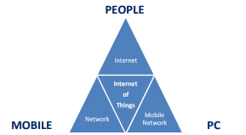

Figure 1: Basics of Internet of Things [1]

Internet of things (IoT) gives a big opportunity to many industries such as automotive field to upgrade the development of new technology in vehicles. IoT is a system of interrelated computing devices, mechanical and digital machines that provides unique identifiers and the ability to transfer data over a network. The uses of IoT in industry significantly influence many applications in modern living. The emerging IoT is going to impact the quality of human lives in many aspects which provide seamless integration of information and communication technologies shortly.

The motivation behind of this project is based on the demanding of IoT in automotive industry. The development of IoT actuator for vehicle on chassis dynamometer can make user’s life easier. This is because there is advantage of an IOT controlled test bench would be that there is no need for the engineer to stay at the lab where the test is running. This leads to some advantages like that the test engineer is saving time for himself and money for the company because he does not need to setup the test and travel to the location of the lab which could be somewhere else around the world. Accessibility at any time from any location proceeds to the possibility to check, share and discuss live data from the test bench together with other colleagues. It is even possible to have a look on the information during different tasks like meetings.

The research project will therefore seek to explore and investigate the following:

* To develop remotely control actuator to control paddle for vehicle on chassis dynamometer
* To study the uses of IoT technology in vehicle
* To implement IoT for the controller to control actuator

## Project Scope:

The project will consist of developing the remotely controlled actuator via Internet to control car pedal when running on the chassis dynamometer. This project needs approximately RM1000 and should be done in 9 weeks stating from 4 March 2019 – 19 May 2019.

## Project Deliverables:

* Create an actuator to control car pedal
* Develop a system to control the actuator via internet

## Project Acceptance Criteria:

* Successfully develop the actuator to control car pedal
* Successfully develop system which can control the actuator via internet

## Project Constraints:

* Limited budget
* Time / resources / personnel limitations
* Imposed design approach that is beyond the project to change
* Limit or restriction on a facility such as laboratory and workshop
* Procurement practices, procedures or processes that must be followed

# Literature Review

Implementation of IoT system is basically depends on its architecture. In the early phase of research the three layer architecture was introduced [8] in which have three layers the perception, network and application layers.

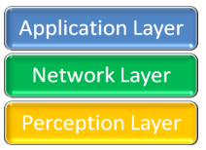

Figure 2: 3 Layer Architecture [1]

1. Perception Layer - This layer also called as physical layer, gathers data or information and recognises the physical world. In this layer all the actuators work according to the information which is collected by the sensors of different object to perform specific operations by the corresponding objects [4].

2. Network Layer - It establishes an interface link between application layer and physical layer. It is responsible for the initial processing of data, broadcasting of data and connecting devices [3].

3. Application Layer - Application layer is the implementation of IoT. The working of sensors and actuators is achieved by application layer. We can understand it as software which works on and for the sensors other virtually intelligent objects.

This three-layer architecture of Internet of Things is not a sufficient for the nowadays technology. So, a new architecture was designed to define the entire concept and development of IoT devices. The new architecture involves 5 layers and is known as 5 Layer architecture [6]. New architecture has perception, transport, processing, application and business layers:

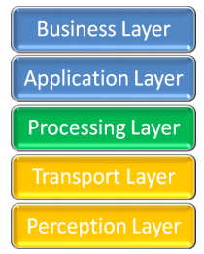

Fig. 3 - 5 Layer Architecture [1]

1. Perception layer works similar as previously described in the three layer architecture. It is used to take information from the sensors and implement it.

2. Transport layer takes the data from the perception layer and pass this data to the next layer which is processing layer and vice versa. This done with the help of networks like LAN, wireless technology, 3G, 4G, LTE, etc [3].

3. Processing layer which is third layer must perform the major task because it will process all the information gathered by the perception layer. There is a huge amount of data which will be stored with the help of some techniques like cloud computing or any database management system (DBMS). Then it will analyse how to fetch data whenever required in order to complete the desired task [5].

4. Application layer is next layer which implements the working of IoT. For this an application is required with the corresponding device in order to complete the desired task.

5. Business layer is the last layer of this architecture which manages the working of entire system along with many other features, one of them is privacy [2].

Both the architectures define the working of IoT system of different types but they are following the same sort of working in order to achieve its goal.

# Methodology

To carry out this project we are using the System Development Life Cycle (SDLC). The phases include planning, requirement analysis, design, development, integration and testing, implementation, operation and maintenance.

## Planning

For this project all information and resources where taken from the research paper and journal that conduct similar or the same scope as our project. Project manager will conduct meeting with the team members. Objectives and necessary task were discussed, and the task will be distributed to the team members. Each team members must understand their job scope.

## Requirement Analysis

Before conducting our project, we need to thoroughly go through all the design requirements which include hardware and software.

Hardware Requirement:

* Linear actuator for physically manipulation of the throttle pedal
* Linear potentiometer for sensing the throttle pedal position

Software Requirement:

* CAD Software – PTC Creo Parametric 5.0
* C/C++ IDE - Visual Studio 2017
* Remote Control UI – Labview (possible)

## Design

From the given requirement, we proposed our design for the task considering all the requirement that is needed to be full-filled. During design phase, we design the actuator and circuit along with the system which control the actuator via internet.

## Development

During development phase, the hardware and software will be built according to the schedule made at the beginning of the project.

## Integration and testing

Here the system will then be tested together with hardware. We will also check for any mechanical or electrical error, together with identifying bugs in the system.

## Implementation

In implementation phase, any problems in both hardware and software identified in the integration and testing phase need to be resolve.

## Operation and maintenance

During this phase, the system will be assessed and evaluate. Any potential area for improvement will be determine. Any potential area for improvement will be determine. Also, there might be some change were made at this stage.

## Materials

|  |  |  |
| --- | --- | --- |
| **No.** | **Items** | **Description** |
| 1. | Linear Actuator | To control the throttle |
| 2. | Sheet metal | Construction of the actuator mount |
| 3. | Servo Motor | To control the throttle |

## Machines

|  |  |  |
| --- | --- | --- |
| **No.** | **Items** | **Description** |
| 1. | Chassis Dynamometer | To run vehicle and collect data |

Electrical Systems

|  |  |  |
| --- | --- | --- |
| **No.** | **Items** | **Description** |
| 1. | Linear potentiometer | Sensor for closing the control loop of the actuator position |
| 2. | Raspberry Pi | Microcontroller to receive remote control data and control the actuator |
| 3. | Speed controller (ESC) for actuator | Final stage to drive the actuator motor with the control signal from the microcontroller |
| 4. | Power supply (PSU) | 220V PSU or 12V capability |
| 5. | Input connector/cable to dyno | Possible speed signal, to remotely control the speed |
| 6. | 5V Relay | Reduce current flow |

## Tools

|  |  |  |
| --- | --- | --- |
| **No.** | **Items** | **Description** |
| 1. | Welder | Required for the metal construction of the actuator mount |
| 2. | Plasma cutter/table | Required for cutting sheet metal for the actuator mount |

# Manual design calculation and CAD drawing

# Detailed cost estimation

|  |  |  |  |  |
| --- | --- | --- | --- | --- |
| ITEMS | IMAGES | ESTIMATED UNIT PRICE (RM) | QUANTITY | TOTAL PRICE (RM) |
| Linear actuator |  | 110 | 1pcs | 110 |
| Linear potentiometer |  | 20 | 1pcs | 20 |
| Servo Motor |  | 120 | 1pcs | 120 |
| 5V relay |  | 17 | 1pcs | 17 |
| Wire |  | 10 | 10m | 10 |
| TOTAL ESTIMATED BUDGET (MAXIMUM RM500) | | | | RM 277 |

# Expected Testing Results

At the end of this project we are expected to have a remotely control actuator which controls the car throttle pedal position on chassis dynamometer.

# Conclusions

The actuator that will be developed can be controlled by the controller via internet in a long range. Lot of work need to be done for the betterment and progress of this project; still more standardization of technology, and hardware are required to make completely reliable and secure domain of Internet of Things. Some global guidelines need to be used for this purpose. The future is totally depending on Internet of Thing, so lot of thing to do at implementation level.

# References

[1] Int. J. Advanced Networking and Applications, Krishan Kumar Goyal, Volume: 09 Issue: 06 Pages: 3663-3668 (2018) ISSN: 0975-0290

[2] A. Al-Fuqaha, M. Guizani, M. Mohammadi, M. Aledhari, and M. Ayyash, "Internet of things: A survey on enabling technologies, protocols, and applications," IEEE Communications Surveys & Tutorials, vol. 17, pp. 2347-2376, 2015

[3] Miao W., Ting L., Fei L., ling S., Hui D., 2010. Research on the architecture of Internet of things. IEEE International Conference on Advanced Computer Theory and Engineering (ICACTE), Sichuan province, China, Pages: 484-487.

[4] Yinghui H., Guanyu L., 2010. Descriptive Models for Internet of Things. IEEE International Conference on Intelligent Control and Information Processing, Dalian, China, Pages: 483- 486

[5] Pallavi Sethi and Smruti R. Sarangi, “ Internet of Things: Architectures, Protocols, and Applications,” Journal of Electrical and Computer Engineering Volume 2017, Article ID 9324035, 25 pages.

[6] Handong Zhang and Lin Zhu, "Internet of Things: Key technology, architecture and challenging problems," 2011 IEEE International Conference on Computer Science and Automation Engineering, Shanghai, 2011, pp. 507-512.

# Appendix

# Project Gannt Chart

|  |  |  |  |  |  |  |  |  |  |
| --- | --- | --- | --- | --- | --- | --- | --- | --- | --- |
| ACTIVITIES | 4-24  March | 25-31 March | 1-7 April | 8-14 April | 15-21 April | 22-28 April | 29-5 April/May | 6-12 May | 13-19 May |
| Project Briefing, Team Building, Introduction to LabView an Raspberry Pie |  |  |  |  |  |  |  |  |  |
| Project Proposal |  |  |  |  |  |  |  |  |  |
| Programming of Remotecontrol (LabView, Python, Android/Windows) |  |  |  |  |  |  |  |  |  |
| Choose actuators and sensors |  |  |  |  |  |  |  |  |  |
| Sketching & CAD Drawing of actuator mounting |  |  |  |  |  |  |  |  |  |
| Order of Parts and Materials |  |  |  |  |  |  |  |  |  |
| Assembling Parts |  |  |  |  |  |  |  |  |  |
| Testing |  |  |  |  |  |  |  |  |  |
| Report Preparation |  |  |  |  |  |  |  |  |  |

# Team organisation

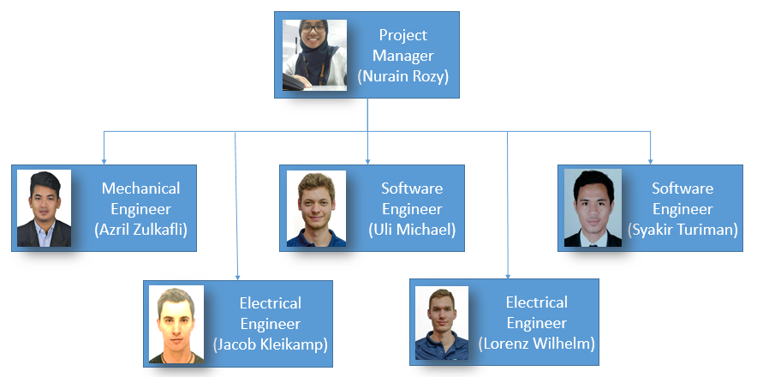

# Others